# xpedx.com Next generation

# *Inventory Calculation and Transfer Circles Detail Design Document*

**Authors: Sterling Commerce**

**Date Created:** 05/20/10

**Last Updated:** 06/01/10

**File Name:** C:\Documents and Settings\bfurman\My Documents\Temp\Methodology v1.1\Project Management\TEMPLATE - DOCUMENT - Use Case Definition.docxpedx Inventory Calculation and Transfer Circles Detail Design v1.3.doc

Approval Signatures (Mandatory)

|  |  |  |  |  |
| --- | --- | --- | --- | --- |
| **Title** | **Name** | **Signature** | **Date** | **Comments / Issues / Concerns** |
| **xpedx Owner(s)** | Steve Bugher |  |  |  |
| Cheryl Tullis |  |  |  |
| **Sterling Commerce Owner(s)** | Guy Read |  |  |  |
|  |  |  |  |

**Note**: The sign off indicates approval of all sections of the document.

Document Revision History

This chart tracks the changes introduced by the revisions to the document as the project progresses through the stages of the System Development Life Cycle (SDLC).

| Version | **Date** | **Description (Changes Made)** | **Author(s)** |
| --- | --- | --- | --- |
| 1.0 | 05/20/2010 | Initial Draft | Sterling |
| 1.1 | 05/20/2010 | Ready to Deliver | Sterling |
| 1.2 | 06/01/2010 | Incorporated feedback from Steve | Sterling |
| 1.3 | 06/01/2010 | Incorporated changes from 6/1/10 meeting with Steve, George and Chris, Cheryl and Jasmine | Sterling |

Related or Reference Documents

| Document Name | Description | Owner | Location |
| --- | --- | --- | --- |
| SCI_Xpedx Solution Definition Document v1.5 | Solution Definition document | Sterling Commerce |  |
|  |  |  |  |

TABLE OF CONTENTS

1. Introduction 4

1.1 Document Purpose 4

1.2 Document Audience 4

2 Inventory Calculation and Transfer Circles 5

2.1 Functions & Solution 5

2.2 Master System 6

2.3 Implementation Details 6

2.3.1 Entity objects. 6

2.3.2 Actions involved and Functions 6

2.3.3 API Details 6

2.4 Process Flow 6

2.5 Screen Shot 7

2.6 Open Questions 8

2.1 Assumptions 8

2 Glossary of Terms 8

# Introduction

## Document Purpose

This document is the governing functional design document for Inventory Calculation and Transfer Circles functionality. It presents significant decisions and constructs used in developing the functionality. Testing, builds, configuration management are not covered in this document.

The document will also serve the purpose of keeping a list of assumptions that were made during design discussions.

## Document Audience

This document is intended for management and technical staff working on this project, xpedx IT and Business, webMethods, Legacy(MAX and ACCESS), HP, IW, xpedx/IP Network Team. Sterling will use the document during design and configuration for design consideration.

# Inventory Calculation and Transfer Circles

## Functions & Solution

Inventory Calculations does not happen in Sterling. They are calculated and sent to Sterling via the P&A Call. Sterling gets the inventory picture for an item in an order by warehouse location along with the no. of lead days. The first warehouse is in the response is always the primary (ship from) branch for the customer.

Once we get the results back from P&A response, we will aggregate the warehouse inventory into 3 buckets, they are ‘Immediate (Customer’s Ship from division)’, ‘NextDay’, ‘2+Days’. The ones qualifying for Immediate are the ones where the lead days are ‘0’. Next day bucket is for the inventory available at the warehouse where lead days is 1 and 0 days. For 2+ Days the lead day is 2 and 2+ days. Use the screen shot below for the ui display.

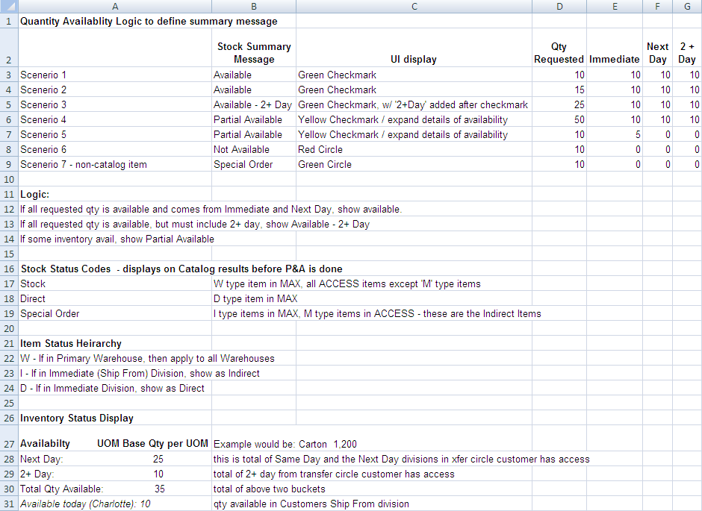

The following pages will show the inventory picture broken down into these 3 buckets as a hover.

* Product Detail Page – The details will show up on the page instead of a hover.
* Shopping cart page – The details will show up in a hover. The page shows the icons with a hover on mouse over.
* My Item List Page - The details will show up on the page instead of a hover.
* Catalog Lightbox - The details will show up on the page instead of a hover.

The hover will also show the requested UOM, order multiple and the total inventory available from all warehouse locations. Please see screen shot below.

In COM, the stock picture will be shown by warehouse location as it comes from the response. There will be no aggregation into buckets.

## Master System

Legacy is the master of record for the Availability calculations. Sterling is responsible to show the available inventory in a manner xpedx wants.

## Implementation Details

## Entity objects.

* NA

## Actions involved and Functions

* XPEDXPriceandAvailabilityUtil.java – This util class has functions that will call the P&A web service with the input object and return the response from P&A. This also has utilities to build the buckets for immediate, nextday and 2+day.

## API Details

* NA

## Process Flow

Not Applicable

## Screen Shot

***Availability hover (cart page)***

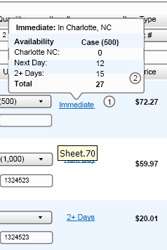

***Availability (Product Detail Page)***

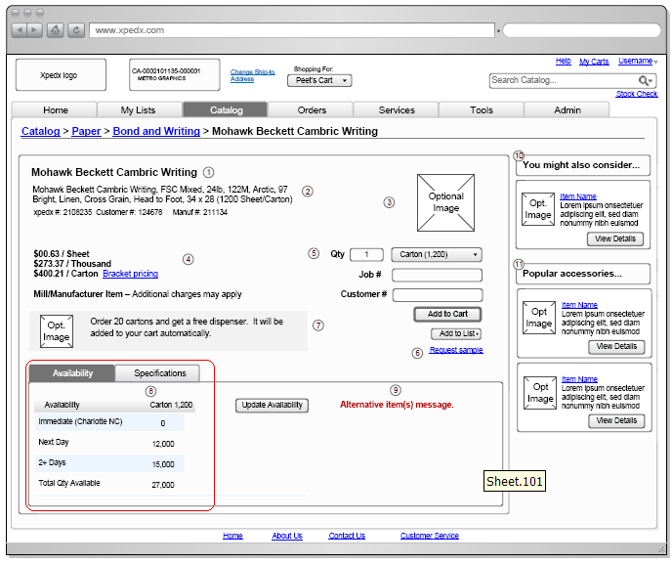

***My Items List Page***

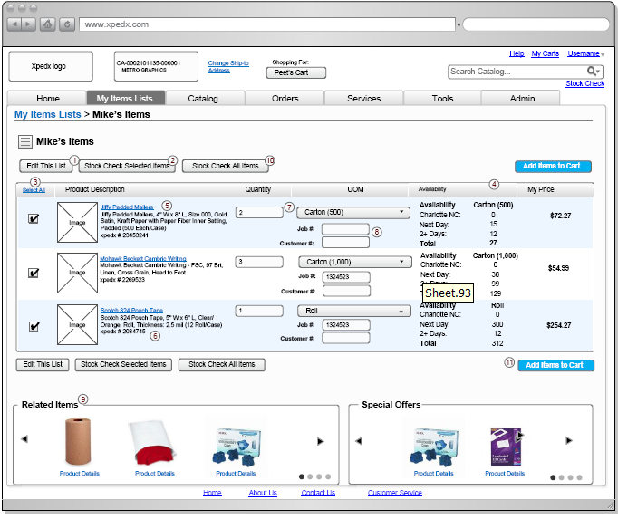

***Catalog LightBox***

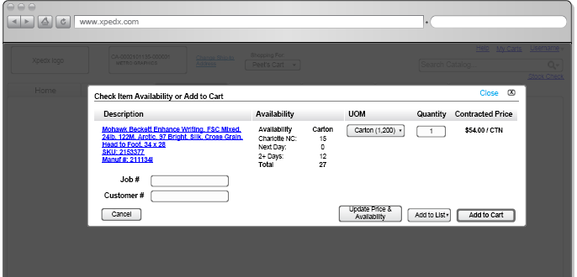

## Open Questions

1. What is the criteria/rule for showing ‘not available’ option in the availability column? Answer: If stock comes as ‘0’ from all the warehouses, then show ‘Red Circle’ which means not available.
2. Do we show the alternate, replacement item options for an item in the cart if the item is not in stock? Answer: These links are shown if the replacement and alternatives exist. This is not tied to if the item is in or not in stock.
3. Impact of the change request to manage the web transfer table in Sterling is not know at this point since it is a pending change request. Once it is approved, we will need to evaluate the impact and changes to the logic.

## Assumptions

1. P&A response data will not be saved or hold in the session.

# Glossary of Terms

|  |  |  |
| --- | --- | --- |
| S. No. | Term | Definition |
| 1. | Entity Object | Database and Java entity objects to store the required data. |
| 2. | Action Class | Struts controllers which redirects the parameters and does some business logic before calling the business APIs. |
| 3. | BR1 | Business Release 1 |
| 4. | IW | Industrial Wisdom – UI firm engaged on the project. |
| 5. | P&A | Price And Availability |
| 6. | OOTB | Out of the Box Sterling system. |